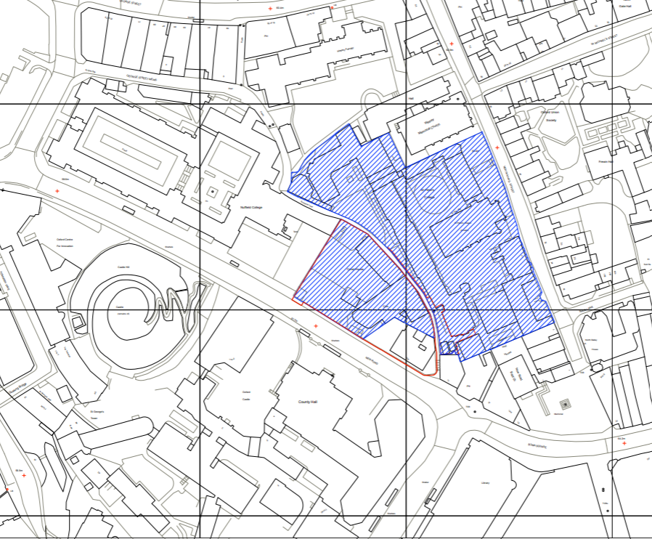
Appendix 1 – Location Plan (19/02307/LBC) Castle Hill House

